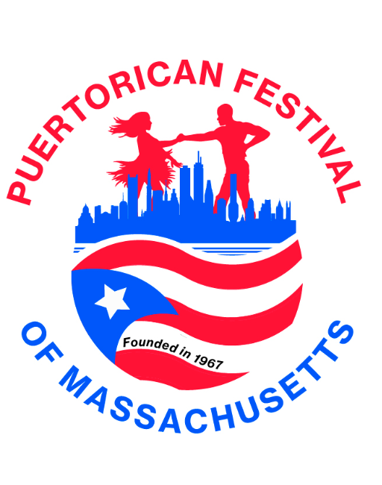 Puerto Rican Festival of Ma Inc.
Sponsorship for the 2023 Puerto Rican Festival Queen Coronation event.
June 17, 2023, at 7:00 P.M. Florian Hall, 155 Hallet St, Dorchester, MA

Company Name: _____________________________________________________________________________________
Company Address:_______________________________________________
Contact Name: Contact Phone Contact email:
(Please Circle one) all monies raised to pay for the event supplies and future awards.

1. $1,000.00 Company logo on step & repeat banner for people to take pictures in front of & Full page in the souvenir book.
2. $500.00 Company 1/2 page in souvenir book - back page outside cover
3. $300.00 Company1/2page in souvenir book- Inside Cover
4. 250.00 Company 1/4 in souvenir book- Middle
5. $200.00 Company 1/4 Page in Souvenir Book
5. $150.00 Business Card advertised in the souvenir book
6. $100.00 Friend of the Puerto Rican Festival/ Supporters (name printed in Souvenir book)
7. Other_____________________________
8. Gift Certificate, raffle items, Gift Basket_________________________________

Additional Sponsorship Opportunities Level of sponsorship
El Padrino: Event – Only two available
$3,000
• Lead Logo placement on the Banner for the event!
• Logo/company name on all flyers and centerpieces.
• 5 -Live mentions on stage -
• 2- Facebook post
• 2 - Table sponsorship (table label) - 10- tickets- to the event
• 1- Full page in the event Souvenir booklet

Mariscal: Del Reinado
$2,500
• Logo displayed on the step and repeat!
• 2 Table sponsorship- 5 tickets
• 3 Live mentions-
• 1-full page in the event Souvenir booklet
Please make check payable to the Puerto Rican Festival of Ma. /Pageant
Please mail to: Puerto Rican Festival of Ma. 
P.O. Box 156
Roslindale, MA 02131
Email: Prfestivalofma@gmail.com -Pageant Director: Marilyn Rivera -617-833-0382
EIN# 04-2701436- for a tax deduction (we are a 501-C-3- non-profit organization)

